**Custom Made Curtains – Measuring Guide and Important Information**

1. **Fitting a Pole or Track**

We advise that your pole or track is fitted in place before you start measuring. If fitting a new track or pole, this should be positioned 15cm (6 inches) above the window and extend 15 - 20cm (6 - 8 inches) either side of the window to enable the curtains to be well drawn back.

We recommend you use a steel measuring tape which is considerably more accurate than a fabric measuring tape.

Our curtains are sold in pairs, and the measurements are for a pair of curtains.

1. **Width**

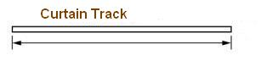

***Single Track:*** For a single track, measure the length from end-to-end. This is the width you give us in **cm**.

**Curtain Track**

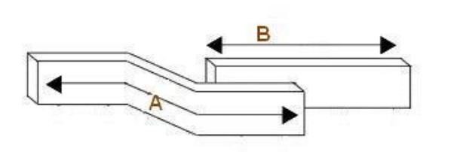

***Overlapping Track:*** For an overlapping track, measure A and B and then add them together to give the width. This is the width you give us in **cm**.

**B**

**A**

***Poles:*** For poles, measure A – the distance between the finials. This is the width you give us in **cm**. We will add 2.5 cm to ensure your curtains overlap in the middle.

**A**

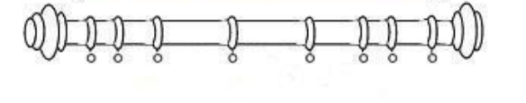

1. **Drop (Length)**

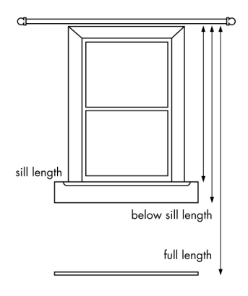First, you need to decide where you wish the curtains to finish – at the sill, below the sill or to the floor (see diagram below). We recommend that:

Sill length curtains finish 1cm above the sill.

Curtains that fall below the sill finish 15cm below or 2 cm above the radiator.

Floor length curtains finish 1cm from the floor.

***Drop for Pencil, Triple and Inverted Pleat Headings***



Pencil Pleat

Inverted Pleat

Triple (French) Pleat

***For Tracks***: measure from the top of the track to where you want the curtain to finish.

***For Poles***: measure from the eye of the small metal ring at the bottom of each curtain ring to where you want the curtain to finish

***Drop for Eyelet Curtains (for Poles only)***

Our eyelet curtains will fit poles up to 30 mm in diameter.

We do not recommend tab top headings for silk curtains as they are not suitable for lining



Eyelet

***For Poles***: measure from the top of the pole to where you want the curtain to finish.

1. **Lining and Tiebacks**

All our curtains are supplied with a 100% heavy duty cotton lining as standard. We recommend you select blackout lining if you intend to fit the curtains in a bedroom. This should ensure a good nights sleep.

Your curtains come with a free set of silk tie-backs.

[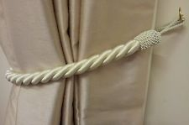](http://www.ebay.co.uk/itm/STUNNING-CREAM-THICK-LARGE-ROPE-SATIN-CURTAIN-DRAPE-TIE-BACK-TIEBACK-32-/330920987862)

**Important information**

•  We strongly recommend that you order free fabric samples of your requested fabric before placing an order to ensure the colour and texture is what you require, as computer monitors can never provide a completely accurate rendering of colour and shade.

• Please check your measurements using our measuring guides to ensure that the correct sizes are ordered and are in CENTIMETRES (cm).

• The majority of our curtains will have seams. This is unavoidable because most of our fabrics are supplied in a standard width of 137 cm. The seam is hidden in the trough of the folds of the gather and is not easily visible even when drawn.

•  Fabric colour can vary very slightly between production batches. There may be a very slight tonal difference between your swatch and final product fabric.

•  Thermal lining lets in as much light as a standard cotton lining and is not a blackout lining option.

•  We do not attach the linings at the bottom of the curtain. This allows the curtain to breath and hang better in different moisture and temperature conditions.

• Natural fabrics, hanging in direct sunlight may fade slightly over time. You can mitigate against this by specifying a blackout lining, and for additional protection, we would recommend adding an interlining.